

**Fundamental of programming**

**Submitted by:**

|  |  |
| --- | --- |
| Name: | Ali Zeeshan Rauf |
| Section: | ME-15(C) |
|  | 467537 |

**Submitted to:**

Dr. Muhammad Affan

**HOMETASKS:**

1. Write a program in C++ that prints the numbers from 1 to 150 except the multiples of 10.

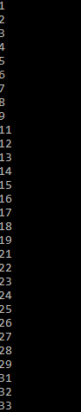

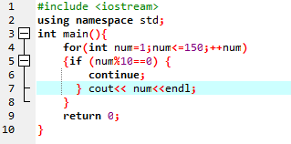

1. Write a C++ program to find the sum of digits of a number.

The sum of digits means adding all the digits of any number, for example, we take any number like 358. Its sum of all digits is 3+5+8=16.

1. Write a program in C++ to check whether a number is prime or not.

